assignment07

Jeff Nguyen

17/10/2020

**University of Southern California**  
**Marshall School of Business**  
**FBE 506 Quantitative Method in Finance**

Assignment 07  
Student Name: Ngoc Son (Jeff) Nguyen  
Student ID: 6524885309

# **Question 1**

a11 <- 15  
a12 <- 1  
a21 <- 1  
a22 <- 2  
  
x1 <- .2  
x2 <- .5  
  
detA <- a11*a22 - a12*a21

## a. Find determinant of A

## b. Find the inverse of A

## c. Find the trace of A

## d. Find the quadractic form X’AX

## e. Find $x_{1}:x_{2}$ that min(X’AX)

Let $k=\frac{x_{1}}{x_{2}}$. We have $x_{1}=k*x_{2}$. Substitute in $x′Ax$:

Find the critical point of x’Ax: $z=f(x_{1},x_{2})=15*x_{1}^{2}+2*x_{1}*x_{2}+2*x_{2}^{2}$ The first order condition is:

Solving the two above equation together yields $x_{1}=0$, $x_{2}=0$ and $z=0$. Thus the point $(0,0,0)$ is the extrema.

To test for the second order condition, form the Hessian:

We can see:

Thus H is positive definite and have a minimum at (0,0,0).

## f. Find $x_{1}:x_{2}$ that min(X’AX) s.t. $x_{1}+x_{2}=1$

Similar to e. but adding the constraint $g(x1,x2)=x_{1}+x_{2}=1$

The Lagrange becomes:

Find the critical point of $L(x_{1},x_{2},λ)$ The first order condition is:

Also

Solving these yields: $x_{1}=\frac{1}{20}$, $x_{2}=\frac{19}{20}$ and $λ=\frac{271}{70}$

The bordered Hessian matrix is:

Thus the min x’Ax happens at

## g. Find the eigenvalues of A.

We have the 2x2 system $x′=A*x$ where

Solve the characteristic equation of this system for the eigenvalues:

## h. Find the eigenvectors of A.

For $λ_{1}=\frac{17+\sqrt{173}}{2}$:  
We need to solve:

By inspection, the notrivial solutions to this system and hence the eigenvectors for the eigenvalue $λ_{1}=\frac{17+\sqrt{173}}{2}$ are all nonzero scalar multiples of:

For $λ_{2}=\frac{17−\sqrt{173}}{2}$:  
We need to solve:

By inspection, the notrivial solutions to this system and hence the eigenvectors for the eigenvalue $λ_{1}=\frac{17+\sqrt{173}}{2}$ are all nonzero scalar multiples of:

# **Question 2**

## a. Find $A′$, $C′$

## b. Find $C^{−1}$

The matrix of cofactors from C is:

Thus, the adjoint of C is:

Assume C is invertible then:

## c. Find AB’, A’B, CA’, BCA’

## d. Find tr(C)

## e.Find a vector orthogonal to A

V is orthogonal to A if V.A = 0. Thus, find value for V that satisfy:

From observation, we can see there is a V(1,1,-3) satisfy the condition.

## f. Find the eigenvalues of A.

The characteristic polynomial of C is:

The eigenvalues therefore must satisfy the cubic equation:

Verify:

C <- matrix(c(1,3,-1,2,3,1,-1,1,0),3,3, byrow=TRUE)  
ev <- eigen(C)  
ev$values

## [1] 4.658587 -1.757702 1.099115

## g. Find the eigenvectors of C.

Using R, we see the corresponding eigenvectors:

ev$vectors

## [,1] [,2] [,3]  
## [1,] 0.62852346 0.6713753 -0.6035847  
## [2,] 0.77713615 -0.4117461 0.2341098  
## [3,] 0.03190081 0.6162145 0.7621536

# **Question 3**

## a. Find the GMV solution, no short sale.

Given parameters

# Mean Returns  
mean_rStock1 <- .023  
mean_rStock2 <- .021  
mean_rf <- .008  
  
# Variance of returns  
var_rStock1 <- .0072  
var_rStock2 <- .0049  
  
# Standard deviation of returns  
sd_rStock1 <- sqrt(var_rStock1)  
sd_rStock2 <- sqrt(var_rStock2)  
  
# Covariance of Returns  
cov_rStock1_rStock2 <- .0023  
  
# Correlation of Returns  
cor_rStock2_rStock2 <- cov_rStock1_rStock2 / (sd_rStock1 * sd_rStock2)

|  |  |  |  |  |
| --- | --- | --- | --- | --- |
| Asset | Mean Returns | Variance | Pair | $σ_{1,2}$ |
| Stock 1 | 0.023 | 0.0072 | (1,2) | 0.0023 |
| Stock 2 | 0.021 | 0.0049 |  |  |
| Risk Free | 0.008 |  |  |  |

Since the investor’s objective is to minimize risk, we solve for the global minimum variance combination of the two assets. Let $x_{i}$ denotes the weight of the investment in asset i $(i=1,2,3)$, and assume all money is invested in i, meaning $∑x_{i}=x_{1}+x_{2}=1$.

The global minimum variance portfolio $m=(m_{1},m_{2})$ is the solution of the constrained minimization problem:

Find the critical point:

**Recap:**

|  |  |
| --- | --- |
| Asset | Weight |
| Stock 1 | 34.67% |
| Stock 2 | 65.33% |

Graphing the function:

# The Variance function of the portfolio  
fVar <- function(m1) var_rStock1 * m1^2 + var_rStock2 * (1 - m1)^2 + 2 * m1 * (1 - m1) * cov_rStock1_rStock2  
  
# Set the weighting  
m1 <- .3467  
m2 <- .6533  
  
# Plot of the variance function with respect to w1.  
w1 <- seq(0, 1, .05)  
plot(fVar, w1, xlab = "Weight of Stock 1 Relative to Portfolio", ylab = "Portfolio Variance", main = "Minimum Variance Portfolio"); abline(v = m1, col = "red")  
points(m1, fVar(m1), col='green')

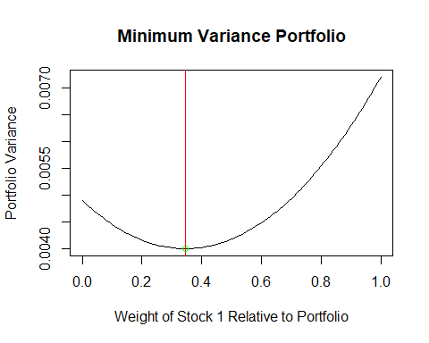

# Plot of the efficient frontier, assume no short sale allowed  
w1WithoutShort <- seq(0, 1, .005)  
fVar <- function(w1) var_rStock1 * w1^2 + var_rStock2 * (1 - w1)^2 + 2 * w1 * (1 - w1) * cov_rStock1_rStock2  
r <- function(w1) mean_rStock1*w1 + mean_rStock2*(1-w1)  
riskWithoutShort <- sqrt(fVar(w1WithoutShort))  
returnWithoutShort <- r(w1WithoutShort)  
plot(riskWithoutShort, returnWithoutShort, type='l', main='Global Minimum Variance (without short sale)', xlab = 'Risk', ylab = 'Return', col = 'green')  
wp <- (var_rStock2 - cov_rStock1_rStock2) / (var_rStock1 + var_rStock2 - 2 * cov_rStock1_rStock2) # Normalizing weight  
Rp <- r(wp)  
sigma <- sqrt(fVar(wp))  
Rf <- mean_rf  
Sharpe <- (Rp-Rf)/sigma  
X <- seq(0, 1, .01)  
Y <- Rf + Sharpe*X  
lines(X, Y)  
points(sigma, Rp, col='orange')

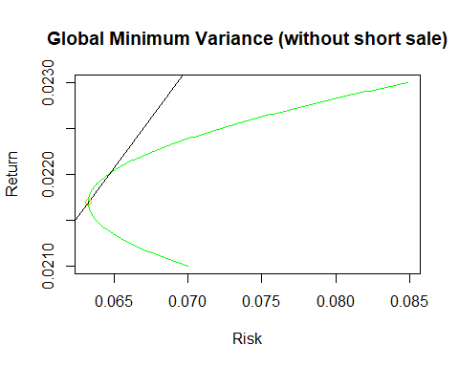

We see indeed the minimum is at $m_{1}=0.3467$

Thus, the optimum weights of each stocks in the portfolio to satisfy the objective of minimum risk is:

|  |  |  |  |
| --- | --- | --- | --- |
| Asset | Weight | Risk | Return |
| Stock 1 | 34.67% |  |  |
| Stock 2 | 65.33% |  |  |
| Portfolio | 100% | 0.063235 | 0.0216933 |

## **b. Construct the efficient frontier. Assume short sale.**

# Plot of the efficient frontier, assume short sale allowed  
w1WithShort <- seq(-2, 2, .1)  
riskWithShort <- sqrt(fVar(w1WithShort))  
returnWithShort <- r(w1WithShort)  
plot(riskWithShort, returnWithShort, type='l', main='Global Minimum Variance (with short sale)', xlab = 'Risk', ylab = 'Return', col = 'red')  
wp <- (var_rStock2 - cov_rStock1_rStock2) / (var_rStock1 + var_rStock2 - 2 * cov_rStock1_rStock2) # Normalizing weight  
Rp <- r(wp)  
sigma <- sqrt(fVar(wp))  
Rf <- mean_rf  
Sharpe <- (Rp-Rf)/sigma  
X <- seq(0, 1, .01)  
Y <- Rf + Sharpe*X  
lines(X, Y)  
points(sigma, Rp, col='orange')

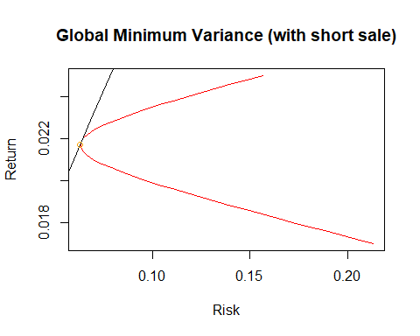

## c. **Graph the efficient frontier of portfolio with and without short sale together.**

# Changed input to display less points  
w1WithoutShort <- seq(0, 1, .1)  
riskWithoutShort <- sqrt(fVar(w1WithoutShort))  
returnWithoutShort <- r(w1WithoutShort)  
w1WithShort <- seq(-2, 2, .1)  
riskWithShort <- sqrt(fVar(w1WithShort))  
returnWithShort <- r(w1WithShort)  
  
  
plot(riskWithShort, returnWithShort, main='Global Minimum Variance', xlab = 'Risk', ylab = 'Return', col = 'red', pch = 17)  
points(riskWithoutShort, returnWithoutShort, col = 'green', pch = 17)

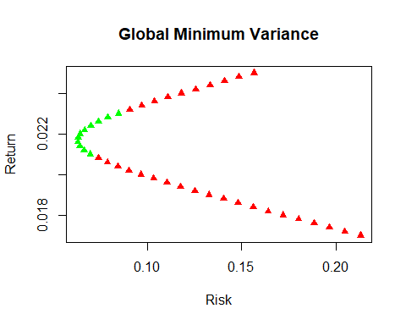

## d. **Graph the CAL and find the point of tangency.**

w1 <- .3467  
Rp <- r(w1)  
sigma <- sqrt(fVar(w1))  
CAL_slope <-(Rp - mean_rf) / sigma  
CAL <- function(x) {mean_rf + CAL_slope * x}

The portfolio returns is:

The portfolio returns variance is:

The slope of the Capital Allocation Line is:

**Thus the Capital Allocation Line equation is $CAL=r_{f}+Slope_{CAL}*x=0.008+0.2165478*x$.**

**The tangency point is where the optimum weight is, i.e. $(σ_{p},Rp)$  or $(0.063235,0.0216934)$**

Graphing

# Plot of the efficient frontier, assume no short sale allowed  
plot(riskWithShort, returnWithShort, main='Global Minimum Variance', xlab = 'Risk', ylab = 'Return', col = 'red', pch = 17)  
points(riskWithoutShort, returnWithoutShort, col = 'green', pch = 17)  
plot.function(CAL, add= TRUE, col = 'blue', lwd = 4)  
points(sigma, Rp, col='orange', lwd = 4)

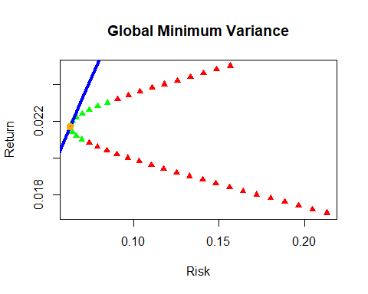

# **Question 4**

## a. Find the GMV solution.

library(matlib)  
  
vcov <- matrix(c(.04, .02, .001, .02, .03, .01, .001, .01, .025), 3, 3, byrow=TRUE)  
vcovInverse <- inv(vcov)  
vcovInverse

## [,1] [,2] [,3]  
## [1,] 39.70678 -29.93280 10.38485  
## [2,] -29.93280 61.02627 -23.21319  
## [3,] 10.38485 -23.21319 48.86988

Formulating the Markowitz portfolio problem:

Let $μ_{p,0}$ denotes a target expected return level. Formulate the problem:

To solve this, form the Lagrangian function:

Because there are two constraints ( $w′*μ=μ_{p,0}$ and $w′1=1$) there are two Langrange multipliers $λ_{1}$ and $λ_{2}$. The first order condition for a minimum are the linear equations:

Simplify, we have:

Rewrite in matrix form:

or

The solution for $z_{w}$ is:

topMatrix <- cbind(2*vcovInverse, rep(1, 3))  
bottomVector <- c(rep(1, 3), 0)  
AmMatrix <- rbind(topMatrix, bottomVector)  
bVector <- c(rep(0, 3), 1)  
zmMatrix <- solve(AmMatrix)%*%bVector  
mVector <- zmMatrix[1:3,1]  
mVector

## [1] 0.3885350 0.3821656 0.2292994

Thus, the optimum weights of each stocks in the portfolio to satisfy the objective of minimum risk is:

|  |  |
| --- | --- |
| Asset | Weight |
| Stock A | 38.8535% |
| Stock B | 38.21656% |
| Stock C | 22.92994% |

## b. Find the GMV solution with constraint.

vcovInverse

## [,1] [,2] [,3]  
## [1,] 39.70678 -29.93280 10.38485  
## [2,] -29.93280 61.02627 -23.21319  
## [3,] 10.38485 -23.21319 48.86988

mean_rStockA <- .0375  
mean_rStockB <- .0420  
mean_rStockC <- .0300  
mean_rf <- .0225  
returnsVector <- rbind(mean_rStockA, mean_rStockB, mean_rStockC) # Establish returns vector  
riskPremiumMatrix <- returnsVector - mean_rf

We have the z vector:

z <- vcovInverse %*% riskPremiumMatrix

The lambda value is thus:

lambda <- sum(z)  
w1 <- z[1] / lambda  
w2 <- z[2] / lambda  
w3 <- z[3] / lambda

Therefore, the weight of these stocks are:

**Recap:**

|  |  |
| --- | --- |
| Asset | Weight |
| Stock A | 12.3628107% |
| Stock B | 78.0497035% |
| Stock C | 9.5874858% |